From: https://medium.com/@marisol.nostromo/what-became-of-the-british-empire-3d2b4c1ffd5a

What became of the British Empire?

Marisol Nostromo
Following
Dec 9, 2018 · 7 min read

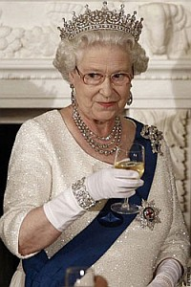
Last December, Secretary of State Michael Pompeo made a speech before the German Marshall Fund in which he spoke of the “Liberal International Order.” A couple of years earlier, the New York Council on Foreign Relations published a blog post in which they set out to define something called the “international rules-based order.” Apparently, these various Orders are threatened by the emergence of new powers that are, frankly, just a little too Asiatic. And evidently that is why we still have NATO, which was formed to protect us from an East Bloc which went out of business 30 years ago. But where did these Orders come from?
Did you ever wonder what happened to the British Empire? Did it just quietly go out of business after World War II? No, actually. It was privatized, in the final chapter of a process which began in 1600 with the charter of the British East India Company. Today, it is comprised of a hybrid mix of raw materials, finance and media cartels, plus an assortment of NGOs, NATO, and the institutions of the Bretton Woods system (the latter started with good intentions, which were quickly subverted.) The rest of it was renamed the Commonwealth, and then, of course, you have the United States.
People [like me, born in 1938 –FNC] who grew up in North America have spent their lives bathed in soothing propaganda about the British Empire; they will tend to regard it as benevolent, civilized, and genteel, if a bit snooty. Sir Winston Churchill is seen as a plucky, resourceful, grandfatherly type who rallied the Anglo-Saxon morale during the darkest hours of the Second World War, and deserves personal credit for the defeat of Hitler (the Russians could not possibly have done that.)
The reality is somewhat different. The British ruled the largest and most successful empire in world history with an iron fist. They had evolved a methodology for keeping it under control, and their methods often rivaled those of Hitler’s Third Reich in the calculated application of brutality and terror.

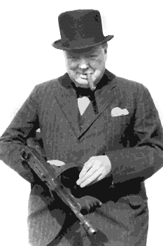
Dr. Shashi Tharoor, an Indian parliamentarian and a former Under-Secretary General of the United Nations, holds Sir Winston Churchill personally responsible for the deaths of 4.3 million of the 35 million Indians killed by the British during their long rule in that nation. Churchill was quoted as saying, “I hate the Indians. They are a beastly people with a beastly religion.” Churchill was favorably disposed toward fascism, but saw the Third Reich as unwelcome competition.
Following World War Two, Britannia was no longer able to rule the waves. They still needed the military muscle to punish nations that opposed their policies, and for that, they turned to the United States. But Franklin Delano Roosevelt did not share Churchill’s yearning to restore the Empire. He told an apoplectic Churchill to his face: “I can’t believe that we can fight a war against fascist slavery, and at the same time not work to free people all over the world from a backward colonial policy.”
Fortunately for Churchill (and unfortunately for everyone else), Roosevelt died in 1945, and his successor, Harry Truman, was an altogether different kettle of fish. On March 5, 1946, Churchill traveled with Truman to the small town of Fulton, Missouri, where he delivered a famous speech that introduced the use of the term “Iron Curtain” into the popular lexicon, and was instrumental in launching the Cold War. The Soviet Union changed rather abruptly from being America’s key ally in World War Two, to being the principal enemy in the new war. Great Britain, on the other hand, was now joined at the hip to the US, in what was called the “Special Relationship.”
Spy agencies such as the CIA and MI6 were intimately interconnected, as were foreign policy think tanks like the Royal Institute for International Affairs (Chatham House) and the New York Council on Foreign Relations. American news media increasingly took their cues from their British counterparts.
The IMF was formed at the 1945 Bretton Woods Conference which set up the framework for the postwar monetary system. That conference was the scene of a conflict between Franklin Roosevelt’s man, Harry Dexter White, and the British Empire’s man, Lord John Maynard Keynes. The familiar bone of contention was whether the Bretton Woods institutions would be set up in such a way as to liberate the developing world from colonialism, or perpetuate it. As discussed earlier, following the death of FDR, the British won the argument, and the Bretton Woods institutions became the new, technocratic, supranational expression of the Empire. Former Tanzanian President Julius Nyerere would one day ask, “Who elected the IMF to be the ministry of finance for every country in the world?”
The IMF’s policy was that developing nations must maintain a “balance of payments equilibrium,” which meant that they were not permitted to run deficits. This had the effect of trapping the Third World into a loan-sharking relationship with the international financial institutions; they were prohibited from making the long-term investments in the construction of infrastructure and a manufacturing base that would make them economically viable, so they were constantly under pressure to sell off their national patrimony in order to maintain interest payments. The culmination of the IMF’s policies was “debt for equity swaps,” where the nation’s creditors would, in effect, “foreclose” and seize raw materials in lieu of interest payments.
The IMF would arrange for debts to be refinanced, but with strings attached (this was the notorious policy called “IMF Conditionalities”.) For example, the IMF would demand austerity, the reduction of living standards in order to divert funds to debt payment. This meant the dismantling of the “social safety net,” an end to food subsidies, looting of pension funds, and cancellation of infrastructure projects. Economist Jeffrey Sachs wrote that the IMF’s “usual prescription is ‘budgetary belt tightening to countries who are much too poor to own belts.’” The IMF demanded that state-owned enterprises be privatized, and any import-export restrictions designed to protect nascent industries must be eliminated. The IMF policies were simply a new version of colonialism.
The IMF was part of a cabal of supranational institutions who worked with private banks and, later on, hedge funds, to plunder
- first the fledgling nations of Africa, South America and South Asia, then
- the former Communist Bloc nations after Communism’s demise at the end of the 1980s. Next on the “kill list” were
- the more vulnerable European nations such as Greece.
So-called “developing nations” that attempt to defy the IMF and stubbornly try to develop must be punished with “regime change.” Inevitably, they will be found guilty of either human rights violations or corruption, and a plague of NGOs will be unleashed upon them as a harbinger of military aggression. Particular ferocity is directed toward former British colonies that refuse to toe the line.
The British and their American henchmen are ardent believers in the doctrine of Geopolitics, which conceives of the world as a zero-sum game where one nation cannot grow stronger without finding ways to make the others weaker. This was holy writ to the emerging neoconservative movement, the most fanatical gang of Anglophiles known to man. Following the collapse of the Soviet Union, neocons argued that no competing superpower or constellation of powers must be permitted to emerge.

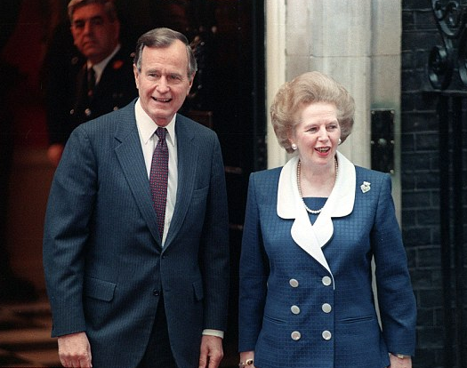
With Margaret Thatcher flying across the Atlantic to “stiffen the resolve” of George H.W. Bush for the first Iraq War, and later Tony Blair performing the same service for Bush Jr. using his “dodgy dossier,” the British focused on the Mideast and guided the Americans into an orgy of “regime change” wars there. The targets were chosen
- not because of oil wealth, as some naive populists are inclined to believe,
- but because the Brits and their neocon acolytes hoped to ignite a chain reaction of instability all along the borders of Russia, India and China.
This was the “Bernard Lewis plan,” named for a famed British spook/academic who settled in at Princeton University back in 1974, and began whispering in the ears of American policy-makers.
But that plan has failed, thus far. Russia, China and India have all survived and are working together in various ways to create an alternate system to the British-designed “Liberal World Order.” Their system, centered around the Belt and Road Initiative, looks to a world of nations interconnected by and collaborating on a grid of technologically progressive rail, highway and telecommunications infrastructure, bringing real development for the first time to the former colonial nations. Meanwhile, the “Atlanticist” countries are poised on the brink of bankruptcy due to their preference for a “casino economy.”

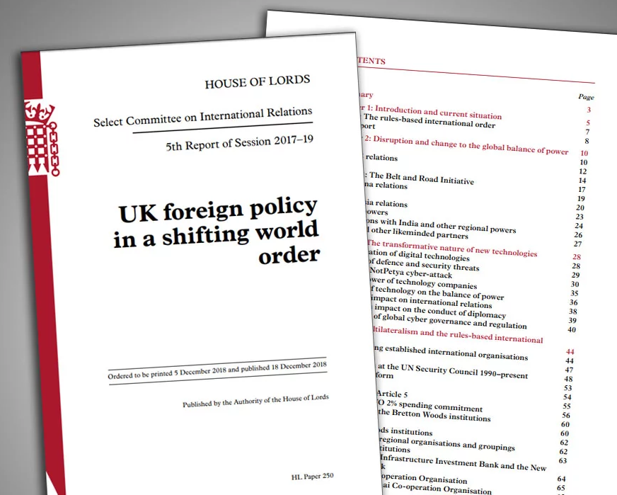
The British House of Lords recently issued a dire forecast, saying that if Trump is re-elected to a second term, that could spell doom for the “special relationship”. There is a special section of the report devoted to the threat posed by the Belt and Road Initiative. The BRI, which offers many Third World countries the only opportunity they have ever had to achieve economic self-sufficiency, represents everything that the Empire has historically striven to thwart.
Chinese President Xi Jinping made offers on two different occasions for the United States to join the Belt and Road. Both times, Present Barack Obama turned him down. President Donald Trump is pursuing a vacillating and confused foreign policy, but when he is not finding opportunities to recklessly confront Russia and China, he is tweeting about his fabulously good personal relationships with Putin and Xi. If he ultimately decides that there is a better deal to be found by joining the Belt and Road than by clinging to the millstone of the Empire, we might see the sun actually set on it.

228
- Empire
- Neoconservatives
- Colonialism
- Imf
- Britain

228 claps
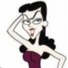
WRITTEN BY

Marisol Nostromo
Following

Marisol is an arts aficionado and a social media habitué.

